Model 1: Mask efficiency vs Percentage Population

Before incorporating facemask utilisation into the SIRS model, changes in the effective reproduction number (Re) as a result of facemask population coverage and mask effectiveness is explored. Re refers to the average number of secondary infections caused by an infected individual in a non-fully susceptible population. Re values and their associated representations are shown in Table 1.

Table 1: Highlights the possible Re values and what these values represent in the context of infection transmission.

|  |  |
| --- | --- |
| **Re Value** | **Representation** |
| Re > 1 | Each infected individual infects more than one other person on average. Infection is likely to spread. |
| Re = 1 | Infection level remains stable. |
| Re < 1 | Each infected individual infects fewer than one person on average. Infection will gradually decline and end. |

The code to explore facemask coverage against effectiveness is shown in Figure 1:

This loop iterates over different values of R0 values against different combinations of facemask coverage (***‘mask_coverage_range’***) and effectiveness (***‘mask_effectiveness_range’***). This loop adjusts the R0 value based on these mask variables to produce an updated Re value.

Figure 1: Function used to calculate the Re for different facemask coverage and effectiveness values.

The R0 represents the average number of new infections caused by an infected individual in a fully susceptible population. The R0 values are prescribed as 2.2 and 4.0, in line with Stutt et al (2020), to show the range of possible values as the true value is uncertain. Both mask ranges are prescribed a range from 0-1 in steps of 0.1, which represents 0-100% (intervals of 10%) population coverage and effectiveness.

Model 2: SIRS

A Susceptible-Infected-Recovered-Susceptible (SIRS) model is developed and utilised for mathematically modelling the transmission of Covid-19 across 540 days, with the consideration of lockdowns and mask wearing protocols being followed. The population is shown proportionally, with the initial conditions being set at 0.99, 0.01 and 0.0 for the Susceptible, Infected and Recovered respectively.

The developed SIRS model uses three core differential equations to simulate the change in the proportion of Susceptible, Infected and Recovered people in a given population. These equations were modelled in JupyterLab and are given in Figure 2 below:

Figure 2: SIRS differential equations used in the model.

The terms in these equations are described as followed:

* ***‘dS_dt’***, ***‘dI_dt’***, ***‘dR_dt’*** = rates of change of the Susceptible, Infected and Recovered population respectively.
* ***‘S’, ‘I’, ‘R’*** = proportion of the population that is Susceptible, Infected and Recovered respectively.
* ***‘beta’*** = transmission rate.
* ***‘delta’*** = rate of immunity loss.
* ***‘gamma’*** = recovery rate.

The SIRS requires prescribed parameters, which are shown in Figure 3 (below) and described in further detail in Table 2:

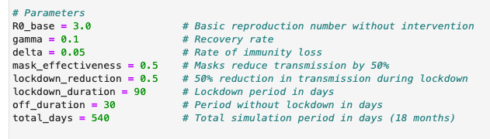

Figure 3: Parameters prescribed to the SIRS model. The parameters that are not highlighted are given in all modelling scenarios. The variables highlighted in red are removed in the scenarios where lockdowns are not considered.

Table 2: Outlines the various parameters used in the SIRS simulations. Basic descriptions of each parameter is provided, along with their associated value used in the model. The reasoning or source for the chosen values is also given.

|  |  |  |  |
| --- | --- | --- | --- |
| **Parameter** | **Description** | **Value** | **Source / Reasoning** |
| R0_base | Basic reproduction rate | 3.0 | Consistent with Stutt et al (2020). |
| gamma | Recovery rate | 0.1 | Assumed due to lack of detailed data |
| delta | rate of immunity loss | 0.05 | Assumed due to lack of detailed data |
| mask_effectiveness | Proportion of transmission reduction due to facemasks | 0.5 | Consistent with Stutt et al (2020) |
| lockdown_reduction | Proportion of transmission reduction due to lockdown | 0.5 | Consistent with Stutt et al (2020) |
| lockdown_duration | Lockdown duration (days) | 90 | Consistent with Stutt et al (2020) |
| off_duration | Duration without lockdown (days) | 30 | Consistent with Stutt et al (2020) |
| total_days | Total simulation duration (days) | 540 | Consistent with Stutt et al (2020) |

For all scenarios, the effect of facemasks is considered, however this is not the case for lockdowns. For both of these considerations, the transmission rate (***‘beta’***) is adjusted.

The function to model lockdowns is shown in Figure 4:

Figure 4: Defined function used to model lockdowns effectively in the model.

It is important to note that the lockdown always starts on the 45th day for any given scenario(***‘first_lockdown_start’****=45*), in line with the work of Stutt et al (2020). The lockdown durations and cycles remain constant at the values given in Table 2.

For each day, the function calculates an the ***‘day_adjusted’***  by subtracting the initial lockdown day. If this value is negative, and therefore falls before day 45, a lockdown is not triggered. The function then calculates the cycle duration of the lockdowns and uses modular arithmetic to identify where the day lies within the cycle. If the day falls within the lockdown duration, the function returns a True value which indicates that the lockdown is active. If the day falls outside of the lockdown period, the function returns a False value and the infection rate remains at its base level.

To model the effects of facemasks and lockdown implementation on the transmission of the virus, the base infection rate is adjusted accordingly. The base beta value represents the infection rate without any interventions and is calculated using the equation shown in Figure 5, and the given values in Table 2:



Figure 5: Equation used to calculate the base transmission rate without any interventions.

This base value is then dynamically adjusted via the following equation (Figure 6):

Figure 6: Equations used to calculate the dynamic transmission rate, with the effects of facemasks and lockdowns considered.

The first stage of the code adjusts the beta value based on the populations facemask coverage (***‘mask_coverage’***) and the masks’ effectiveness (***‘mask_effectiveness’***). The mask effectiveness was kept constant (Table 2), with coverage values of 0, 0.25, 0.5 and 1.0 prescribed to represent a masked population of 0%, 25%, 50% and 100% respectively.

The second stage of the code determines whether the day is in a lockdown period using the function in Figure 4. If so, the facemask adjusted beta value is halved during these periods, in line with the value prescribed in Table 2. This suggests that lockdowns reduce transmission rates by 50%. If a lockdown scenario is not considered, then this section is not included.

The resultant dynamic beta value is then processed through the SIRS differential equations mentioned previously.

**Results**

The results show that as a greater proportion of the population wear masks of greater effectiveness, the reductions of Re are greater for all R0 conditions (Figure 7). The results also suggest that the Re could fall below 1 if a large proportion of the population were to wear effective facemasks (Figure 7). This critical Re boundary is shown to be more difficult to reach if the R0 is larger, with the requirement of 100% of the population to wear a facemask of ~70% effectiveness for when R0=4.0 as opposed to ~50% effectiveness for when R0=2.2 (Figure 7(a)(b)).

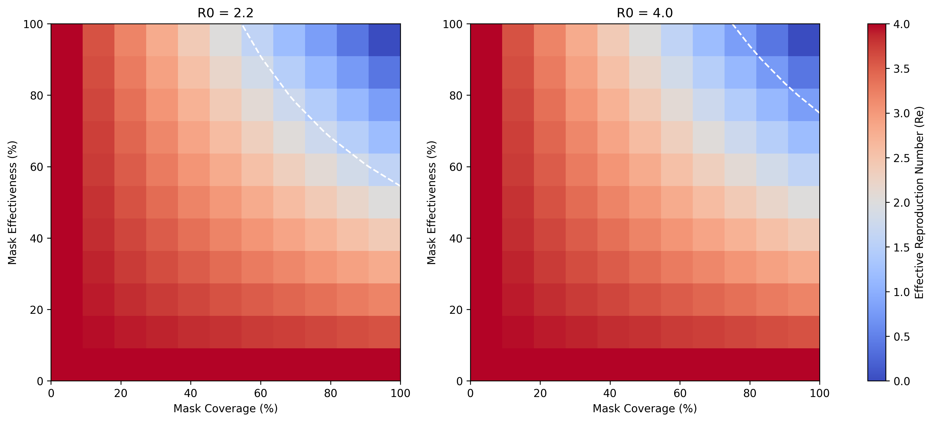

(a)

(b)

Figure 7: Heatmaps showing the calculated effective reproduction number (Re ​) for various combinations of mask effectiveness (%) and mask coverage (%) for initial R0 values of (a) R0=2.2 and (b) R0=4.0. The white dashed line indicates the threshold where Re=1.

R0=3.0 alongside a 50% mask effectiveness was simulated for a variety of masked population proportions across 540 days using the SIRS model (Figure 8). When combined with lockdown measures, the trends in the proportion of the infected population are similar for 25% and 50% masked population, alongside no facemasks worn at all (Figure 8). For these scenarios, the infected population increases dramatically, until it is slowed significantly by the implementation of the first lockdown at day 45. Once the lockdown ends, the infected population increases dramatically, but is unable to reach the same level as the beginning of the simulation due to the 30-day limit. This process is repeated in waves for the remaining lockdown scenarios, with similar levels of peak infection levels. Although these scenarios display similar cyclical trends, the peak levels of infection differ by ~15% between each percentage integral (Figure 8). A fully-masked population throughout the pandemic shows a considerably less-dramatic rises and falls between lockdown periods, and does not display these cyclical trends (Figure 8). Instead, by the end of the third lockdown (day 375), the infected population appears to reach ~0 and this is maintained ; suggesting the gradual ending of the pandemic (Figure 8).

Interestingly, when a fully-masked population is implemented at different timescales, alongside the consistent lockdown cycles, the infected population appears to indicate the gradual decline of the pandemic by the 540th day (Figure 9(a-d)). When facemasks are implemented outside of a lockdown, it is shown to decrease the rate of infection significantly, at a similar rate of the increase in infections (Figure 9(a)). When a masked population occurs at a later date, this results into a greater second wave of infections once the first lockdown in lifted by ~60% per 30-day delay time (Figure 9(a-d)). It is worth noting that for all scenarios, the infected population peaks at ~0.35 around day 30, and then dramatically decreases; which is likely due to a large reduction in the susceptible population and thus a reduction in Re at this point (Figure 9(a-d)).

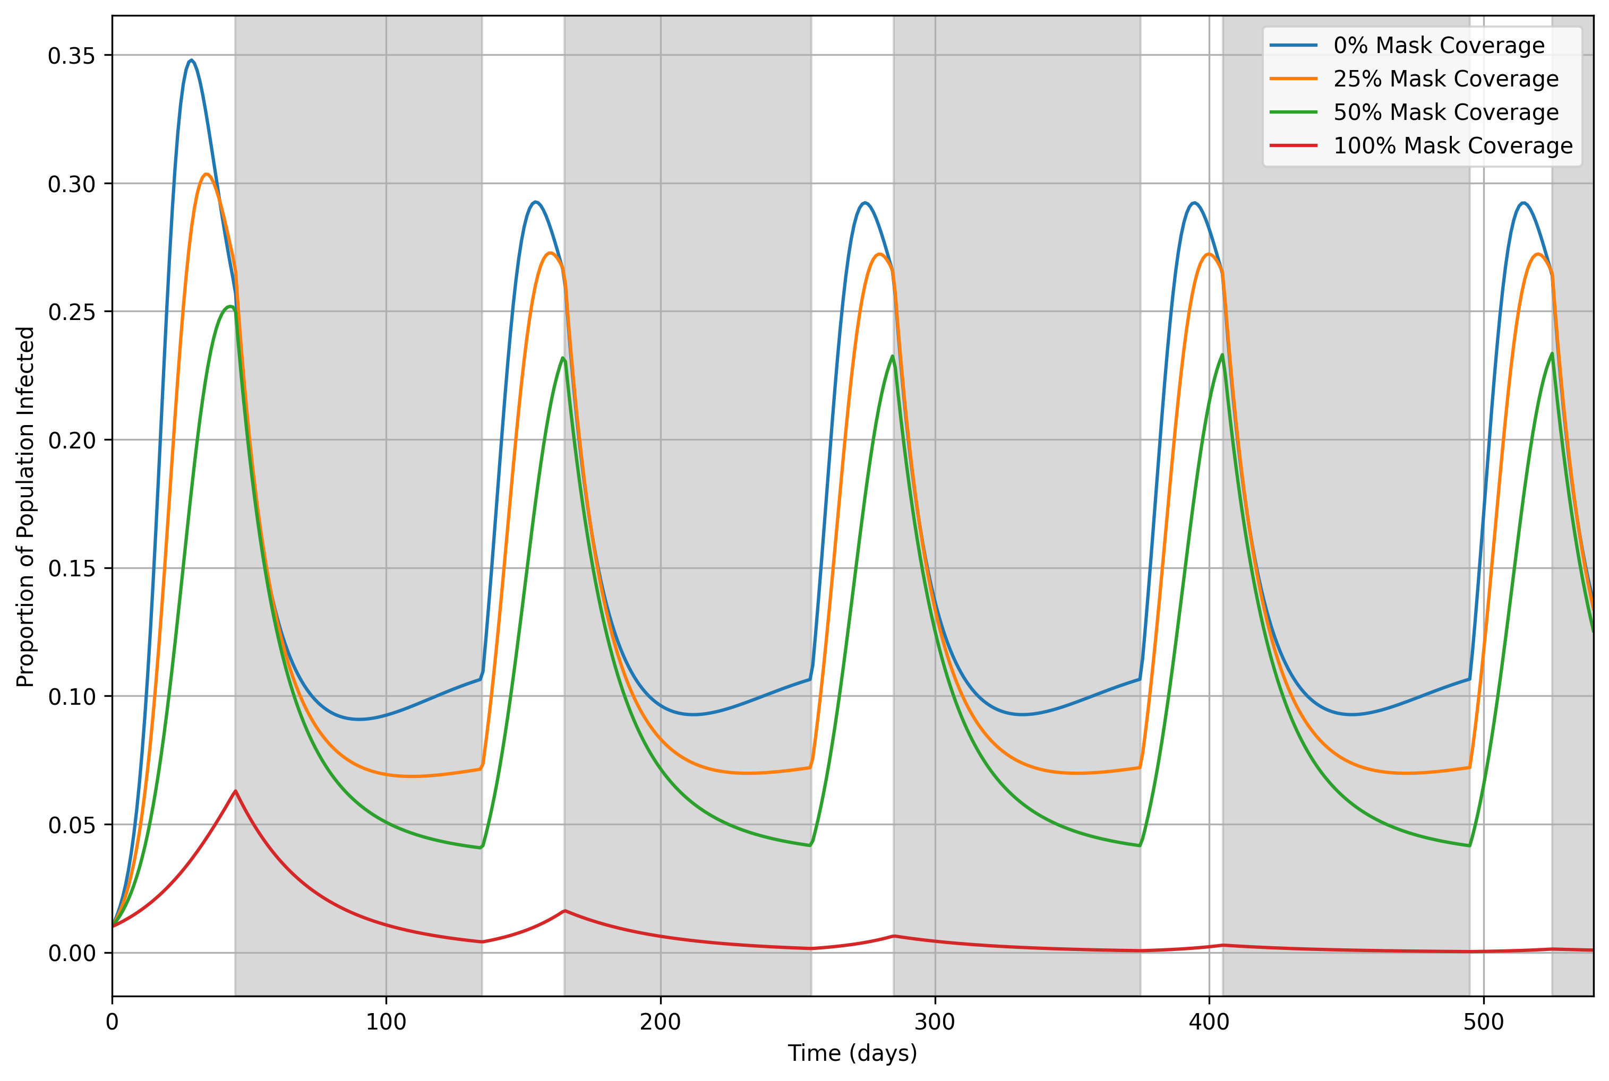

Figure 8: Timeseries showing the proportion of the population infected over 540 days for mask coverage levels of 0% (blue line), 25% (orange line), 50% (green line), and 100% (red line). 90-day lockdown periods, starting at day 45, are highlighted with grey shading, with 30-day gaps between consecutive lockdowns. Facemask interventions start from day 0 and continue throughout the simulation period.

When lockdowns are removed completely, and facemasks are applied from the very beginning of the pandemic, this peak still remains at day 30 for all scenarios (apart from a fully-masked population), but the magnitude decreases in line with increased mask wearing (Figure 10). For a fully-masked population, this peak occurs at ~day 90 but the magnitude is much less drastic (~0.012). Once these infection peaks have been reached, the infected population appears to stabilise from ~day 100, with increasing infections in line with a decreasing masked population (Figure 10).

Figure 9: Timeseries showing the proportion of the population infected over 540 days for a mask coverage level of 100% (red line). Facemask interventions begin on day (a) 30, (b) 60, (c) 90, and (d) 120, continuing throughout the simulation. The start of the facemask intervention is indicated by the dashed blue line. 90-day lockdown periods, starting on day 45, are highlighted with grey shading, with 30-day gaps between consecutive lockdowns.

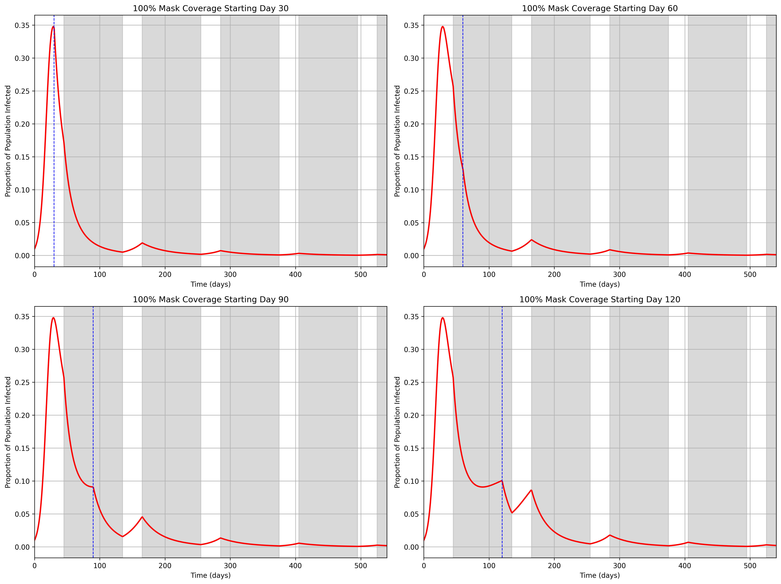

(a)

(b)

(c)

(d)

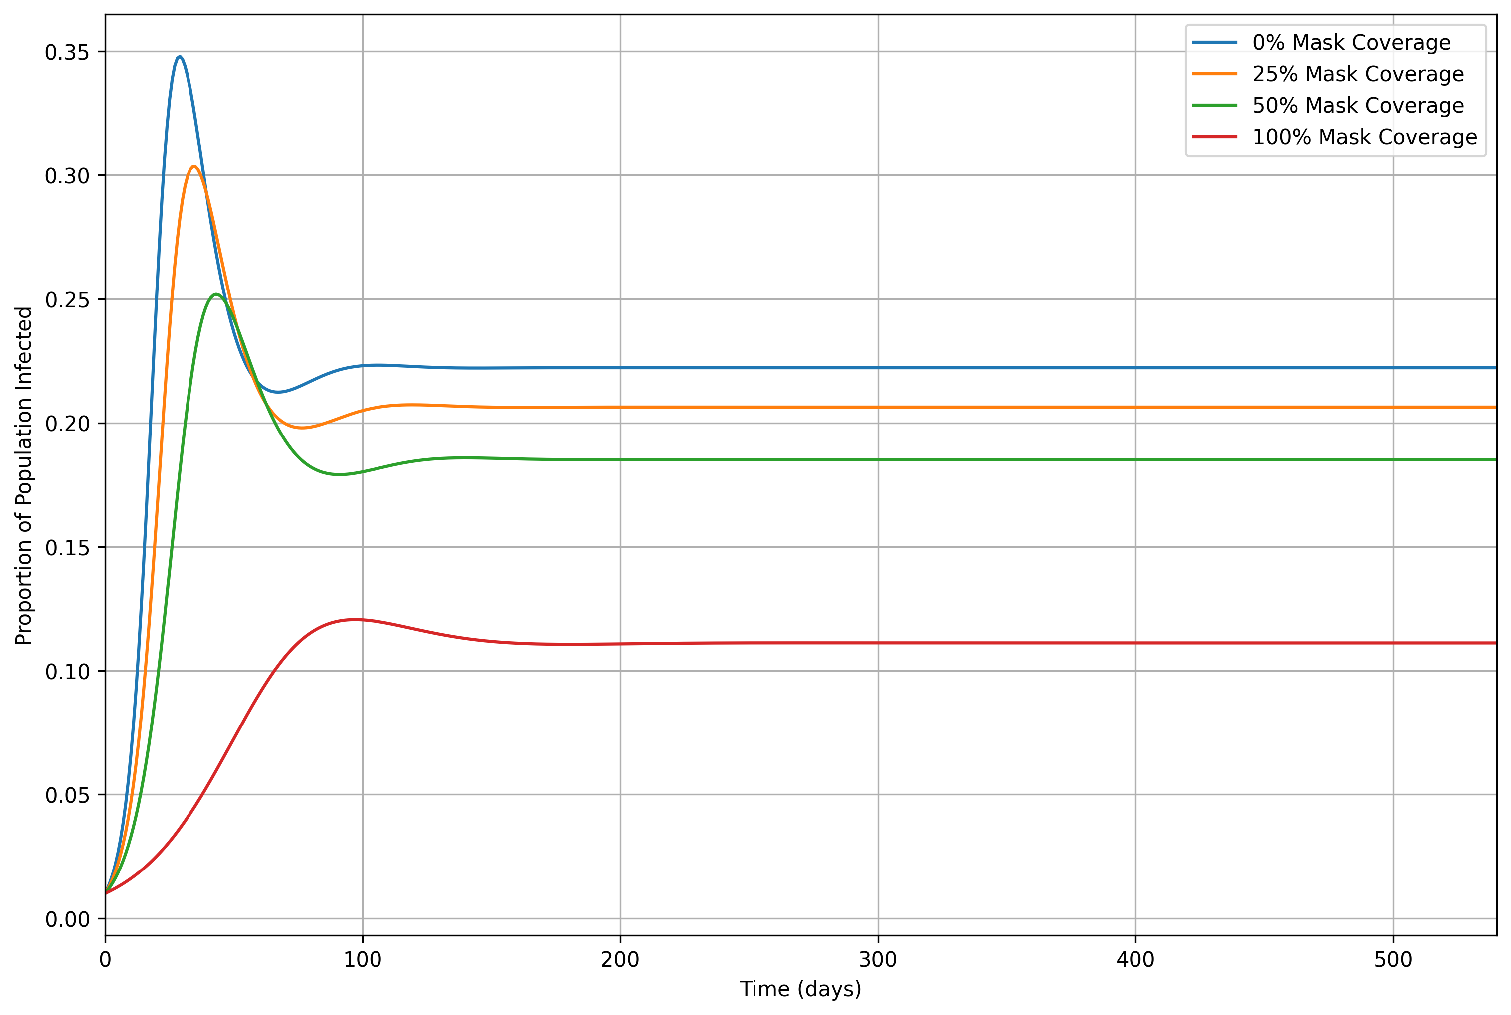

Figure 10: Time series showing the proportion of the population infected over 540 days for mask coverage levels of 0% (blue line), 25% (orange line), 50% (green line), and 100% (red line). No lockdown interventions are included, and facemask interventions start on day 0 and continue throughout the simulation period.

**Discussion**

The findings from this research are largely comparable to similar studies, with high agreement that high mask effectiveness combined with a large proportion of the population wearing masks is enough to reduce transmission to levels that could end endemic conditions. (Stutt et al, 2020).

This research limited the mask effectiveness at 50% and adjusted the proportion of the mask-wearing population. From this, it became apparent that only a fully-masked population, alongside lockdown implementation, is able to dramatically flatten and delay the peak of infections, whilst preventing subsequent reinfection waves. This is highly consistent with similar research which places confidence on these conclusions. Below this 100% coverage, there are continuous cyclical waves of infection, which suggests that there is a critical coverage value where this is broken; which could be explored in further research. This is a key finding from this study, which is not evidenced elsewhere in the literature from current knowledge. This significant finding is solely due to the introduction of the loss of immunity rate into the model; which is not seen elsewhere. Similar research uses an SIR model, which assumes long-term immunity once recovered; despite this being contextually incorrect.

This research examined the effects of adopting facemasks, without the implementation of lockdowns, which showed a flattening of the curve with increasing adoption. At 100% adoption, this was effective enough to flatten the curve further but also delay the peak infection by ~60 days. This is consistent with similar research and emphasises the potential significance of public facemask use on reducing transmission and ending the pandemic (Eikenberry et al, 2020; Stutt et al, 2020)

Is able to achieve infection rates that indicate the end of endemic conditions, when combined with lockdown measures, regardless of the mask implementation occurring.

**References**

* Eikenberry, S.E., Mancuso, M., Iboi, E., Phan, T., Eikenberry, K., Kuang, Y., Kostelich, E. and Gumel, A.B., 2020. To mask or not to mask: Modeling the potential for face mask use by the general public to curtail the COVID-19 pandemic. *Infectious disease modelling*, *5*, pp.293-308.